**Mphasis ATE Capstone Project Medicare Name: Prajwal Diwakar**

**Create a Testing Framework for the Medicare Website**

**Technical Report**

**JMeter**

1) Download the JMeter apache-jmeter-5.6.2 through the browser

2)After downloading Launch the Jmeter in the system through the path, C:\Users\Dell\software\apache-jmeter-5.6.2\bin and click on the jmeter of type windows batch file

3) Create the thread group

4) Create the HTTP Cookie Manager to clear the cookies after each iteration.

5) Create the HTTP Cache Manager to clear the cache after each iteration.

6) Create the user defined variable and the HTTP request inside the thread group.

7) Setup the HTTP request for home page, register page, login page, add to cart page, view page, place order page and logout page.

8) Add the constant timer as child to each request to have the delay and it executes accurately.

9) Assign the user defined variable for the base URL to each HTTP request.

10) Also add the concurrency Thread group to test the localhost:9010 platform

11) Add the listeners such as view result tree, summary report and aggregate report, View Results in Table.

12) Clone below the github link by typing the command git clone <URL> in the command prompt.

**Github Link: https://github.com/Prajwal-Diwakar/Capstone-Project-Medicare**

**Screenshots:**

**User defined Variables**

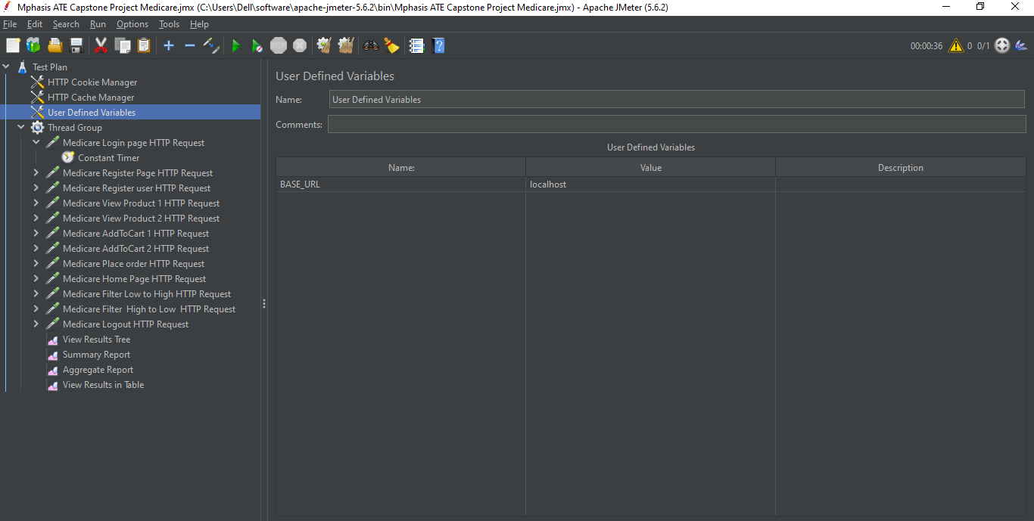

**Http request:**

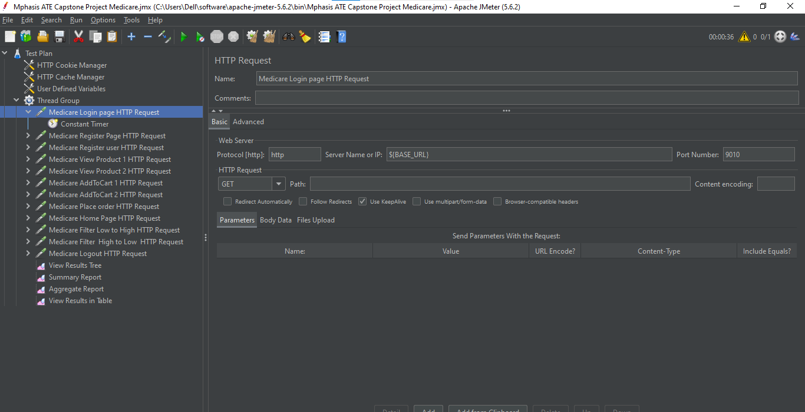

**View Results Tree.**

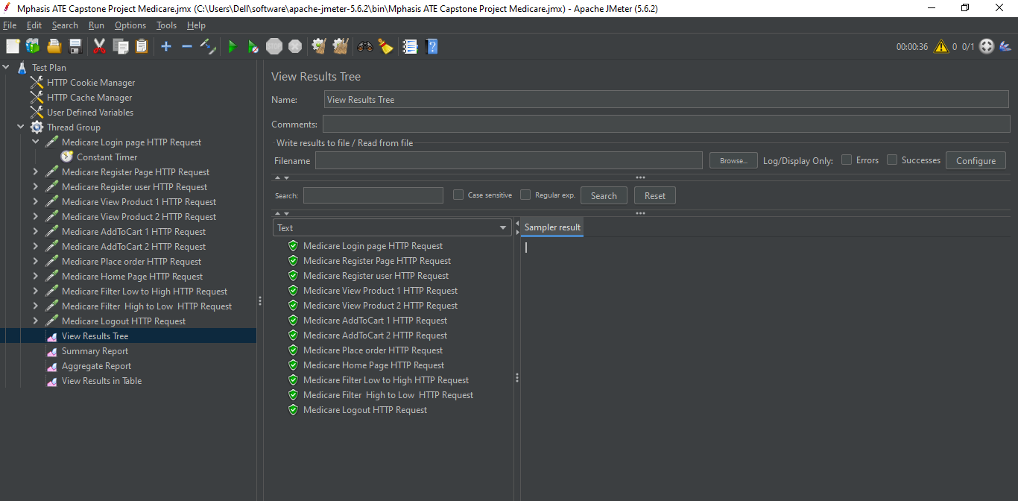

**Summary Report**

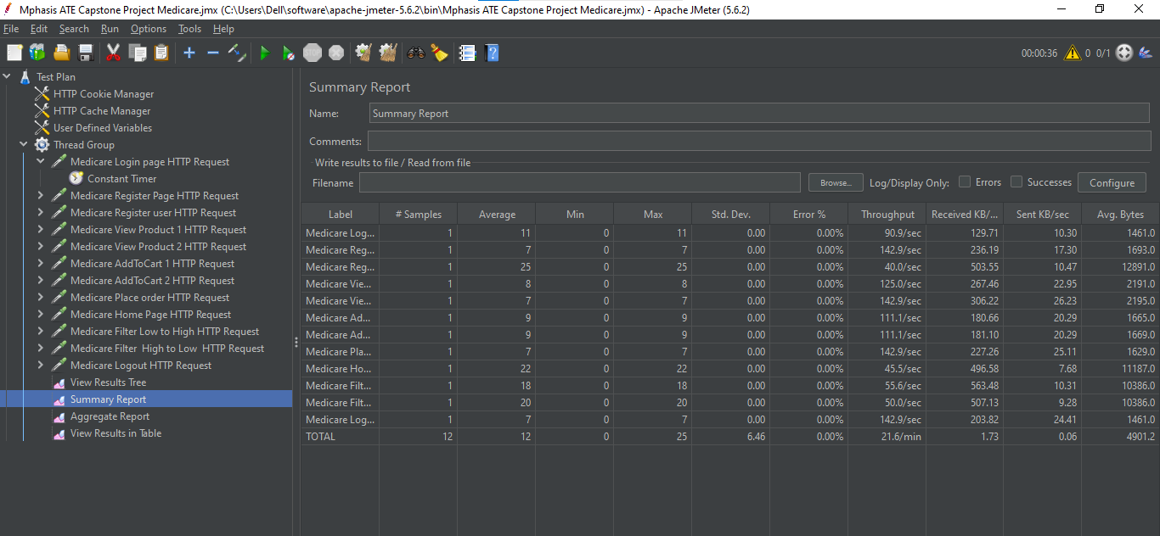

**Aggregate Report**

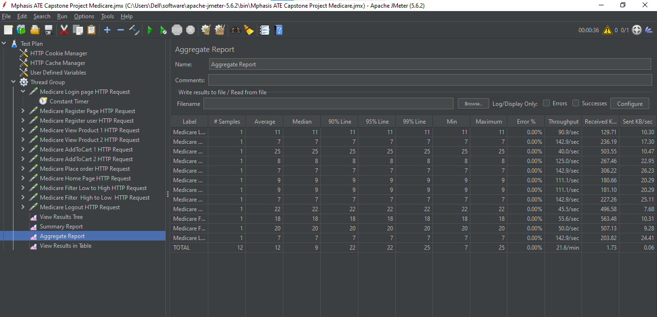

**View Results in Table:**

